**Blockchain**

**Project**



**Counterfeit Medicine Authentication System**

**Submitted By –**

Achintya Verma - B2020063

Aditi Rawat - B2020064

Adonis Claudius - B2020065

Diwakar Bhardwaj – B2020078

Pradyut Mishra - B2020098

Urja Pathak – B2020120

**Topic -** Counterfeit Medicine Authentication System

**Problem statement -** It is a very big challenge to monitor and keep track of genuine medicine in healthcare, because lacking strong monitoring authority. Blockchain security could make the system more transparent and reliable, ensuring transaction security.

**High Level Design –** High level document to add the necessary details to the current project.

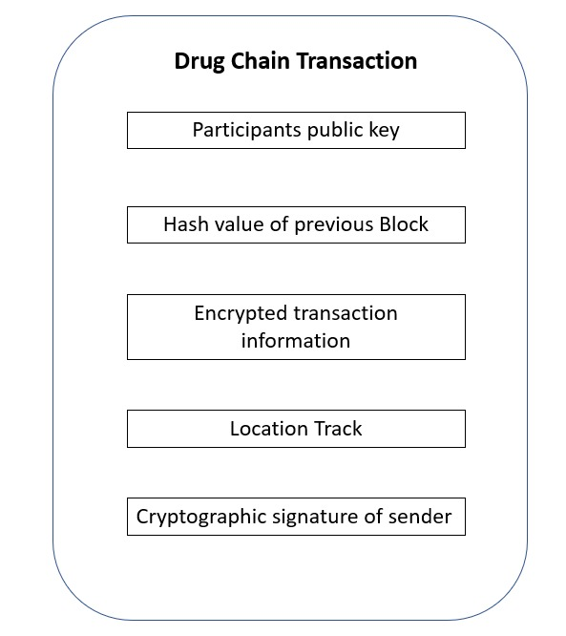

The transaction data stored is similar to bitcoin transaction data. As each participant has public key. Each participant between transactions shares public key, hash value of previous transaction, encrypted QR code by manufacture.

Manufacturers label medicine with encrypted QR code which consists of hash values that are generated by hash function. QR code contains the details of medicine which is manufactured by the drug organizations.

Each medicine has a unique QR code using a hash function to prohibit reused levelling by the manufacturer. This makes the transaction of supply chain secure. This design gives the successful validation of sender’s cryptographic signature. Unauthorized parties cannot get access due to the public key and the QR code prevents the duplication of medicine.

When someone scans the code, it shows the information associated with medicine from the block of this chain. The actual QR code returns the identity number that can be used in blockchain network.

**Low level Design –**

All the participants have to get validated by the drug administration. The public address of digital signature of the participant will be provided by the drug administration authority, the participants shared information will be encrypted in blockchain and the current location of the transaction will also be added to the block. Information of expired medicine will be removed from the medicine and using this the customer can easily scan the QR code to the check the validity of the medicine .

